From: https://www.nytimes.com/2019/11/23/science/manhattan-project-atomic-spy.html
Aggregated into: https://www.msn.com/en-us/news/us/historians-find-another-spy-in-the-us-atomic-bomb-project/ar-BBXcVER

[
The long debate on
the relative importance of American spies and Russian scientists to
Moscow’s 1949 atomic breakthrough.

- Klaus Fuchs, a physicist, was arrested in early 1950, shortly after the first Soviet detonation.
- David Greenglass, a machinist
- Theodore Hall, the youngest physicist at Los Alamos,
- Now atomic sleuths have found a fourth, Oscar Seborer

Searches:
"Klaus Fuchs" "David Greenglass" "Theodore Hall" Oscar Seborer"
"J. Robert Oppenheimer"
]

Fourth Spy Unearthed in U.S. Atomic Bomb Project
His Soviet code name was Godsend, and he came to Los Alamos from a family of secret agents.

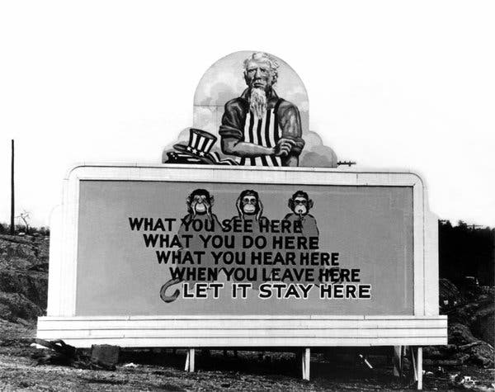
A sign outside the Manhattan Project headquarters in Oak Ridge, Tenn., in 1943. A Soviet spy was stationed there from 1943 to 1944, then transferred to Los Alamos, N.M.Credit...Galerie Bilderwelt/Hulton Archive, via Getty Images
By William J. Broad
- Nov. 23, 2019
The world’s first atomic bomb was detonated on July 16, 1945, in the New Mexican desert — a result of a highly secretive effort code-named the Manhattan Project, whose nerve center lay nearby in Los Alamos. Just 49 months later, the Soviets detonated a nearly identical device in Central Asia, and Washington’s monopoly on nuclear arms abruptly ended.
How Moscow managed to make such quick progress has long fascinated scientists, federal agents and historians. The work of three spies eventually came to light. Now atomic sleuths have found a fourth. Oscar Seborer, like the other spies, worked at wartime Los Alamos, a remote site ringed by tall fences and armed guards. Mr. Seborer nonetheless managed to pass sensitive information about the design of the American weapon to Soviet agents.
The spy fled to the Soviet Union some years later; the F.B.I. eventually learned of his defection and the espionage but kept the information secret.
His role “has remained hidden for 70 years,” write Harvey Klehr and John Earl Haynes in the current issue of Studies in Intelligence, the C.I.A.’s in-house journal; their article is titled “On the Trail of a Fourth Soviet Spy at Los Alamos.” In separate interviews, the sleuths said they were still gathering clues regarding the exact character of Mr. Seborer’s atomic thefts.
Mr. Klehr is an emeritus professor of politics and history at Emory University, and Mr. Haynes is a former historian for the Library of Congress. Both have written books on Soviet spies and American communism, often together. Their tale has an eerie resonance at a time when Russian intelligence agencies are again at the center of American life.

Code name: Godsend.

Image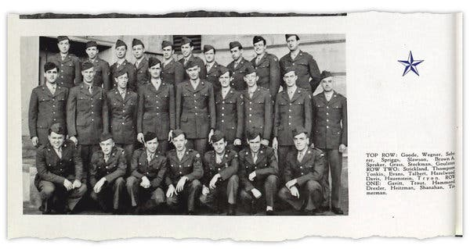
Oscar Seborer, third from left in the top row in this 1944 yearbook, was a member of company G of a U.S. Army specialized training program at Ohio State University.Credit...
Mr. Seborer was born in New York City in 1921, the youngest child of Jewish immigrants from Poland, according to the study by Mr. Klehr and Mr. Haynes and a C.I.A. document they cited. He attended City College of New York, studied electrical engineering and worked at Los Alamos from 1944 to 1946.
In July 1945, the study reported, he was “part of a unit monitoring seismological effects” of the first detonation of the atomic device. His Soviet code name was Godsend, and he came to Los Alamos from a family of spies.
In 1951, Mr. Seborer fled the United States with his older brother Stuart, as well as his brother’s wife and mother-in-law, and defected to the Soviet Union, where, in 1964, he received the Order of the Red Star, a prestigious military award. He died in Moscow in April 2015 under the assumed surname Smith. The study reported that the funeral’s attendees included an agent of the Russian internal security service.

Image
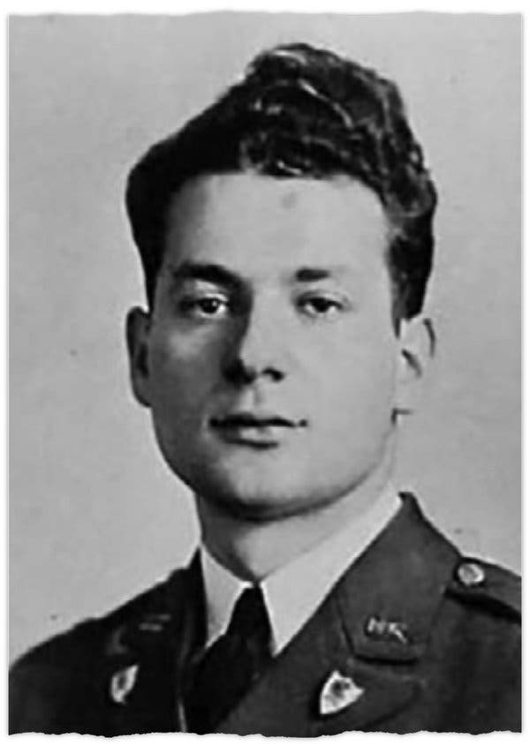
Stuart Seborer, an older brother of Oscar Seborer, in his 1939 City College of New York yearbook photo.
The sleuths were uncovering the story of Godsend even as the decorated spy was being laid to rest.

A mole in New Mexico.
From an examination of archival materials from the K.G.B., the Soviet Union’s main intelligence agency, Mr. Klehr and Mr. Haynes learned about a shadowy group of moles in the United States known as the “Relative’s Group.” Three of the faction’s members — code-named Relative, Godfather and Godsend — were brothers. According to the study, the archival documents said that Godsend was at Los Alamos and that he was providing secret information on “Enormous,” the K.G.B.’s code name for the American project.
In 2012, Mr. Klehr obtained newly declassified F.B.I. files on informants who had successfully penetrated the Communist Party of the United States. Suddenly, he started seeing references to the Seborers, and major parts of the atomic puzzle fell into place: Oscar was Godsend, Stuart was Godfather and their older brother Max was Relative.

Image
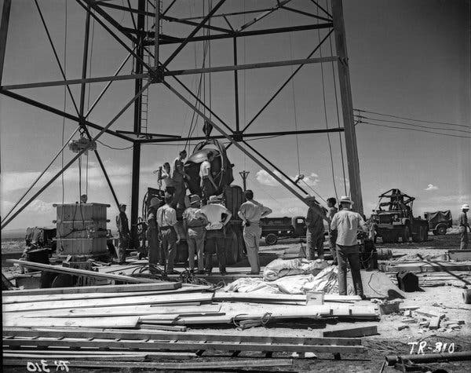
Workers mounting the world’s first atomic device, dubbed “the Gadget,” to a test tower at the Alamogordo Bombing Range in New Mexico in July 1945.Credit...Los Alamos National Laboratory
“It was fun to do,” Mr. Klehr said of the C.I.A. article. He noted, however, that he and Mr. Haynes still await the declassification of government files in the United States that promise to shed more light on the exact nature of Mr. Seborer’s atomic thievery.
“We concluded we might be dead before it’s all released,” he said, and the two scholars decided they “had enough to write the article.”
Mark Kramer, the director of Cold War studies at Harvard, said the study cast new light on “how widespread espionage was in the Manhattan Project.” It helps to reframe a long debate, he added, on the relative importance of American spies and Russian scientists to Moscow’s 1949 atomic breakthrough.
In an interview, Mr. Kramer said that the news of Mr. Seborer’s spying, combined with the known atomic thefts, “makes clear that Soviet weapon scientists were receiving a great deal of valuable information. Espionage, by pointing them in the right direction and avoiding false leads, helped them a lot more than they were willing to acknowledge.”
The identities of the other three Los Alamos spies have long been known. Klaus Fuchs, a physicist, was arrested in early 1950, shortly after the first Soviet detonation. His testimony led to a second spy, David Greenglass, a machinist, who was also taken into custody. Not until 1995 was the third spy, Theodore Hall, the youngest physicist at Los Alamos, identified publicly. By then he had moved to England and was never convicted of espionage.
Image
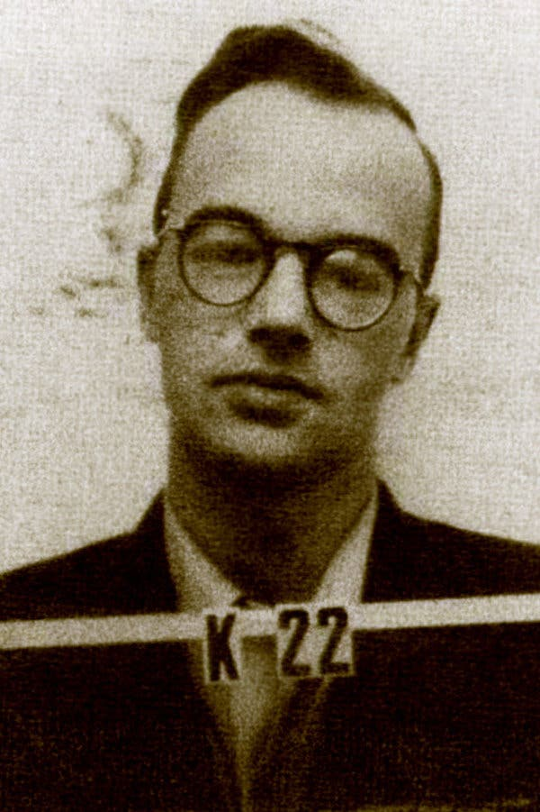
The Los Alamos ID badge of Klaus Fuchs, the first spy uncovered at the secret site, circa 1944.Credit...Everett Collection, via Alamy
Image
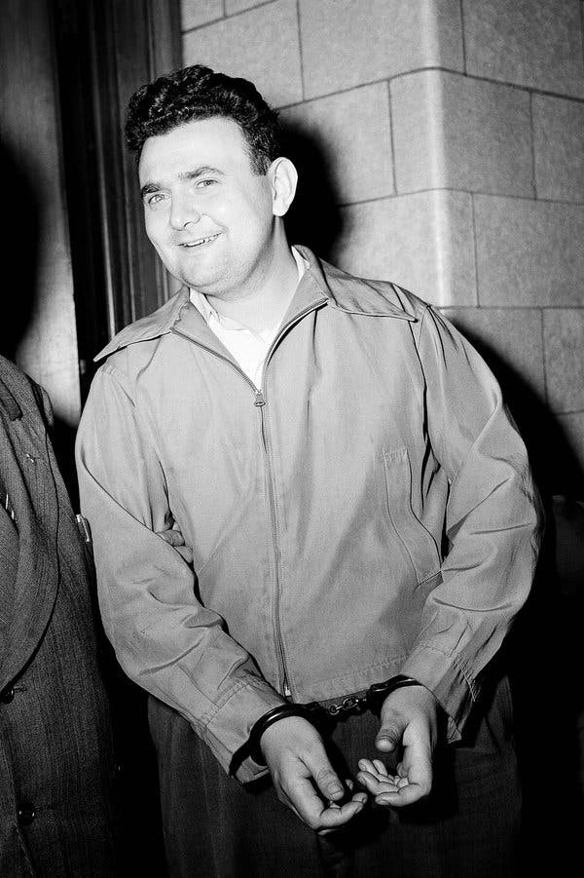
David Greenglass, the second Los Alamos spy, leaving federal court in New York after a hearing in 1950.Credit...Jacob Harris/Associated Press

Image
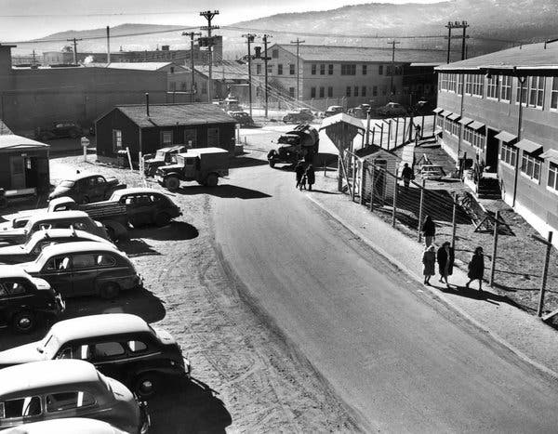
The Technical Area of the Los Alamos laboratory in January 1947.Credit...U.S. Department of Energy
In pursuing the fourth spy, Mr. Klehr and Mr. Haynes uncovered the secret life of an electrical engineer whose “family was part of a network of people connected to Soviet intelligence,” the historians wrote.
Their study for the C.I.A. journal reported that Mr. Seborer joined the United States Army in October 1942 and was assigned to the Oak Ridge complex in Tennessee, a giant industrial arm of the Manhattan Project that became its headquarters. He was transferred to Los Alamos in 1944.
The F.B.I. in 1955 learned that Mr. Seborer had defected to the Soviet bloc, the study said, but kept the information under tight security. The bureau’s information about the defector had come from infiltrators of the Communist Party of the United States, and the bureau worried about their possible exposure. The name of the undercover operation was Solo.

‘He handed over the formula.’
Declassified files on the Solo operation bristle with fascinating hints of Mr. Seborer’s espionage for the Soviets but offer few details, according to the study. It quotes another member of the “Relative’s Group” as telling an informant, “He handed over to them the formula for the ‘A’ bomb.”
In their article, the two scholars noted that, “as of early 2019,” they had received little information under the Freedom of Information Act “about Oscar’s Los Alamos career or the F.B.I.’s investigation of his work there.”
In an interview, Mr. Haynes, who lives in Santa Fe, N.M., near Los Alamos, said he hoped that new files released in the future under FOIA to the scholars would “fill in a whole bunch of gaps.” The F.B.I., he added, “takes its own good time in these matters.”

Image
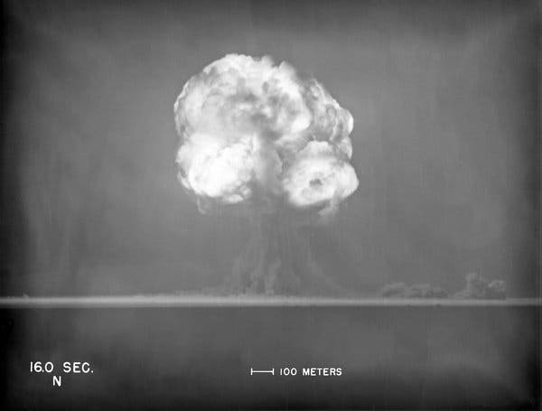
The first atom bomb test, on July 16, 1945. The Soviets copied the weapon’s design for their own first test in August 1949.Credit...Los Alamos National Laboratory
Mr. Klehr said more research in Soviet archives might help clear up a deep mystery in the case: whether Mr. Seborer worked for
- the K.G.B. or
- its rival military agency, then known as the G.R.U. and today as the Main Directorate. Circumstantial evidence points to the military tie, he said.
“The G.R.U. was forced to turn over atomic sources to the K.G.B.,” he said. “So it’s quite possible that the K.G.B. files don’t reveal the spying’s full extent.”
Other clues may lie in Moscow, where Oscar Seborer and his brother Stuart lived for at least six decades. The two scholars have sought to learn about the brothers’ lives as Muscovites. The study said that Oscar did engineering research and Stuart did scientific translations; little is known about the activities of Max, who remained in the United States.
In 2018, Mr. Kramer, the Harvard scholar, was in Moscow and tried to assist the two historians in tracking down Stuart, who conceivably was still alive, as no records of his death could be found. Stuart Smith (formerly Seborer) had a listed telephone number. The calls went unanswered.
Mr. Kramer went to Stuart’s last known apartment and rang the doorbell. Nothing. He talked to neighbors and showed them a photograph. Little could be learned.
There is still much to know about an atomic spy who helped change the world, Mr. Kramer said, including the possibility that Stuart aided his brother in the espionage. He called it “an open question.”

Earlier articles about the Manhattan Project and its legacy

VIDEO
The Atomic Bombing of Hiroshima
Aug. 6, 2017
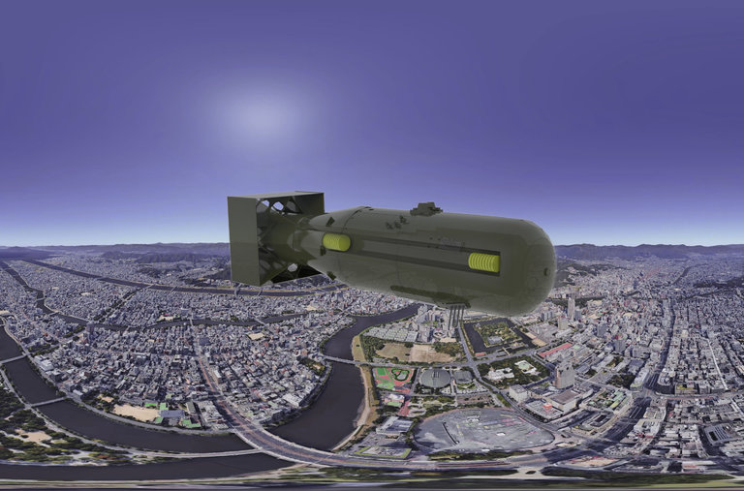

A Manhattan Project Veteran Had a Unique View of Atomic Bomb Work
July 26, 2015
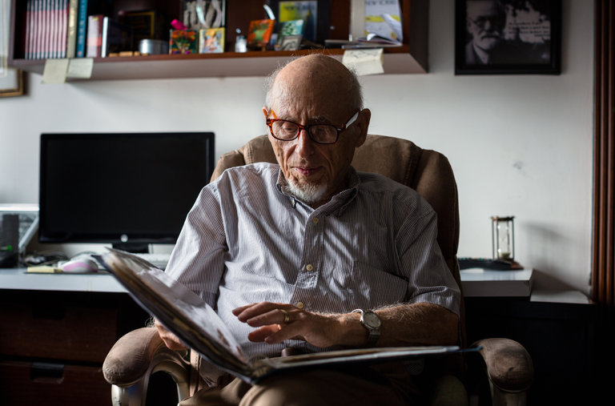

VIDEO
Nagasaki marks 70th anniversary of atomic bombing
Aug. 9, 2015
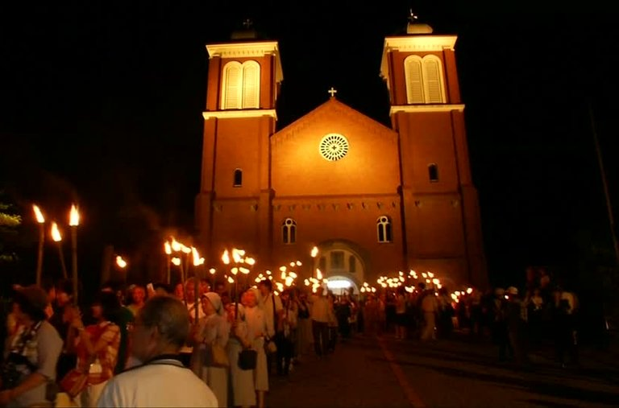

1950 | ‘Atomic Bomb Is Not the Weapon’
Aug. 10, 2017
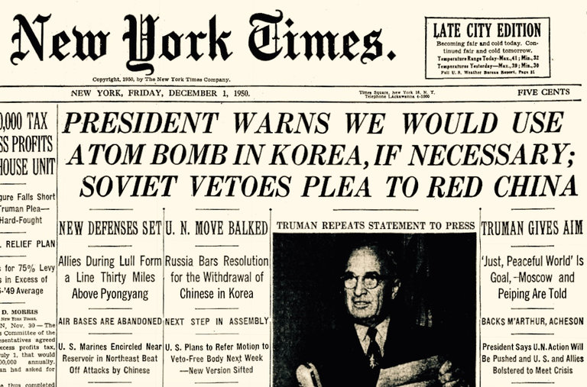

William J. Broad is a science journalist and senior writer. He joined The Times in 1983, and has shared two Pulitzer Prizes with his colleagues, as well as an Emmy Award and a DuPont Award. @WilliamJBroad
A version of this article appears in print on Nov. 24, 2019, Section A, Page 1 of the New York edition with the headline: 4th Spy Unearthed in U.S. Atomic Bomb Project. Order Reprints | Today’s Paper | Subscribe
READ 57 COMMENTS

